Project 1

Title:
RPG Game

Course:
CSC 5 – 46023

Due Date:
7/21/14

Author:
Daniel Canales

1 Introduction

This is a typical generic RPG. It takes inspiration from plenty of other games. In this game you will roll dice to move around the gameboard. The board itself is long, around 50 spaces. During this you will encounter many enemies that appear in countless other games; such as wolfs, snakes, bats, falcons, and turtles. Each have there own unique attack and health. You get the standard options to attack, defend, and use items. Each item gives you different benefits that will help you continue to the end. Once you reach the end you will face off against one of the 2 final bosses in the game. If you manage to beat that, then congradulations, you win the game!

2 Gameplay Rules

Since this a simple text based game, everything will be simple and straightforward. At first you will be asked to enter your character's name. One you've done that you will start off with no item and your health will be set to 100. A dice will then begin to roll in the background. Press the key the screen indicates and hit enter. The program will then tell you what your roll was. You will then move that amount of spaces, once your roll is done you will encounter a random enemy. You will take turns attacking each other like a traditional RPG. You have the choice of attacking/defending/items. Please enter the word of the choice you'd like to make. Do not make any errors and nothing will happen. Attacking will damage the enemy, defending will cut the damage you take in half, and using items will help give you a boost (to use an item make sure to type out the name, same as in making a choice). Depending on the outcome of the battle you will either continue or the game will end. Keep repeating this until you defeat the final boss.

3 Development summary

Total Lines of Code: 731
Main.cpp: 667
Header-Stats: 64

Version 1 – Map

First I created the game board. I did this by creating a int called space. In order for the player to move around the board I created a void called diceroll. This generated a number from 1-6 which would correspond to how far across the board the player will move. I then add the output of diceroll() to space to keep track how far along the player has gone. This would keep on repeating until the player reaches the end of the board (50 spaces).

Version 2 – Enemies

In my second version I began with creating an enemy. I use a wolf as my default character to go against the player. I initialized attack and hp for it. I created a simple case statement for the players choices. I used string compare to check players choice to attack/defend/item. If any of those equaled 0 it set my ans to 1,2, or 3. Depending on what answer was, the wolf would respond differently.

Version 3 – Attack

If ans = 1 then the wolf would output its own attack. Then the health of the player would be subtracted whatever the damage the wolf outputted.

Version 4 – Defend

If ans = 2 then when the wolf attacked the damaged would be ½. I did this by creating the equation playerhp -= (wolfattack/2). I kept all attacks/healths as int rather than floats since I did not want the player or enemy to have decimals or non-whole numbers.

Version 5 – Items

This was probably the hardest for me to program. If ans = 3 then the user would be asked to use an item. I first created the items which as simple int potions that equal certain numbers
(small =20, medium = 40, large = 60). I also made a max potion which is supposed to fill your hp back completely. I did that by getting plhp = (100-plhp). That gave me the remainder to 100 and added it back to me. I reused the string compare to give the player the option to write down the type they wanted to use. I ran into a problem the first time I used a potion at high health. It would add it all and get me over 100. I solved it by creating an if statement so that if the player's hp was over 100 it would set it back to 100.

Version 6 – Battle

I then created the battle function. It was a void that contained a loop of the playerschoice and the enemies choice. It would repeat until either the player or the enemies hp drop to 0.
If the player lost then I would cout a Game Over and end the program. If the player won, then it would take them back to the dice roll and start from there. It would repeat until the games over.

Version 7 - Item Shuffling

This part was intended to go after the battle. It uses a rand() that generated a number between 1-100. I then used a switch statement and depending on the case chose would give out : nothing, a small potion, medium potion, large potion, or max potion. I made the case with nothing happen more so the player doesn't have a huge amount of potions.

Version 8 – Adding the other enemies

It ended up being trickier than I would've thought. I created 4 other enemies and use the same method for choose the item to give. But after that I created a int called entype (which stands for enemy type) and gave it a value depending on the enemy chosen. I then had to go though all my code that originally had just the wolf and create case statements based on the value of entype. Each case had a different situation and damage outputs for every enemy. Though after this my code somehow manage to screw up. When I fought an enemy they wouldn't die. I realized the problem was that now having more than one enemy the loop wouldn't correctly read the enemies reduced HP and it read only the original. I have to create a new int called enemyhp and input enemyhp = (nameofenemy)hp after every situation that the hp dropped. I then used enemyhp in the original battle do loop and it corrected the problem.

Version 9 – Final Boss (Completed)

I decided 2 use to final bosses just because I found it interesting. I used the same method for enemy selection and applied it to a new boss selection void. Since it was basically just adding another stronger enemy I had no problems adding this.

4 Examples
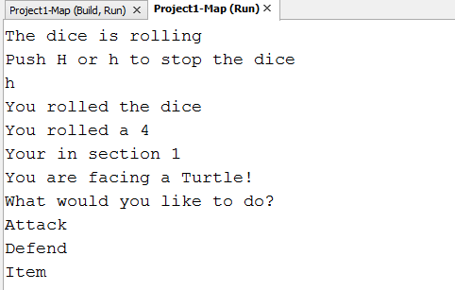
EX1: How the dice and enemy selection work

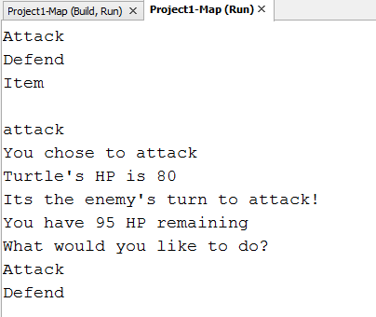
EX2: How making a selection works in battle

5 Flow Chart

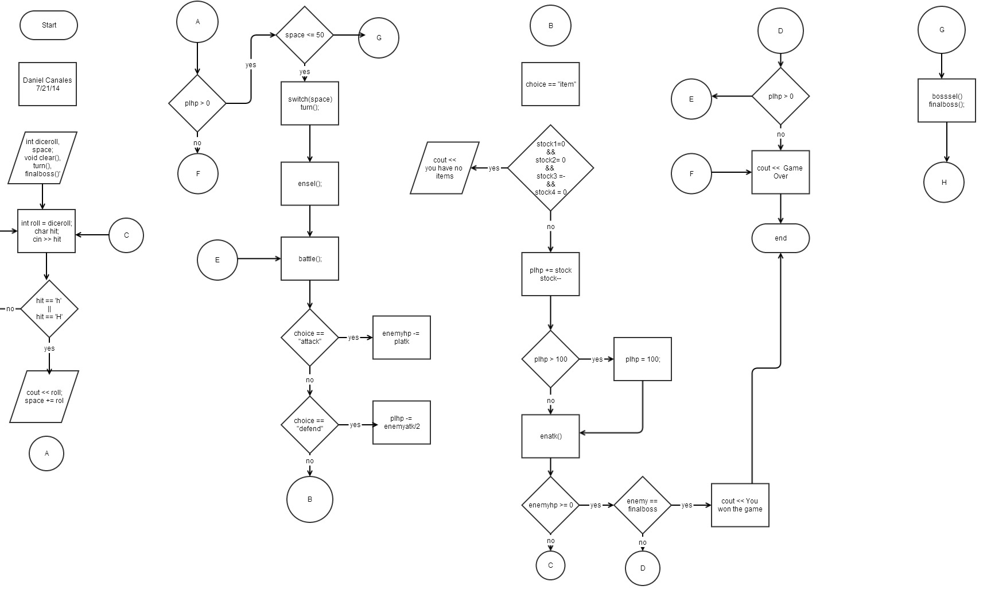

6 Pseudocode

//functions
//only the ones used in main are placed here
int space = 0;
int diceroll();
void clear();
void checkdeath();
void turn();
void finalboss();
//make everything random when needed
srand(static_cast<unsigned int>(time(0)));
//keeps track of how far youve gone
int space();
//create the board-start off 50 spaces split into 4 sections
1-15 section 1
16-30 section 2
31-40 section 3
41-50 section 4
battle
generated enemy with rand() roll
player goes first atk/def/item
enemy attacks
repeat until player or enemy reaches 0
if space <= 50
battle
space > 50
finalboss
battle – repeat again until enemy or player losses
win

Actual Code

Stats Header:
*
* File: Stats.cpp
* Author: Daniel Canales
*
* Created on July 14, 2014, 11:08 AM
*/

//create a header function
#ifndef _Player
#define _Player

#include <cstdlib>
#include <iostream>
#include <ctime>

using namespace std;

/*
*
*/

//player stats
int plhp = 100;
int platk = 20;

//wolf stats
int wolfhp = 40;
int wolfatk = 10;

//snake
int snakehp = 30;
int snakeatk = 12;

//bat
int bathp = 20;
int batatk = 7;

//falcon
int falconhp = 60;
int falconatk = 18;

//turtle
int turtlehp = 100;
int turtleatk = 5;

//final boss - Chimera
int chimerahp = 120;
int chimeraatk = 30;

//differnt final boss other options
//dragon
int dragonhp = 150;
int dragonatk = 25;

//items (potions) gives that amount back as HP
int small = 20;
int med = 40;
int large = 60;
//sub 100 from play hp so Hp maxes at 100 and not go over
int maxhp = (100-plhp);

#endif //close it

Main.CPP
/*
* File: main.cpp
* Author: Daniel Canales
* I have 1 header files Stash
* For making my program neater and organized by catagory
* Created on July 14, 2014, 11:03 AM
*/

#include <cstdlib>
#include <ctime>
#include <iostream>
#include <fstream>
#include "STATS.H"
using namespace std;

/*
*
*/
//functions
//only the ones used in main are placed here
int space = 0;
int diceroll();
void clear();
void checkdeath();
void turn();
void finalboss();

int main(int argc, char** argv) {

//placed here to make everything random when needed
srand(static_cast<unsigned int>(time(0)));
//output if user name and if they won or lost
ofstream outputFile;
outputFile.open("data.dat");

char now;
int death = 0;
//enter name
cout << "Please enter your name" << endl;
cin >> player;

outputFile << player << endl;

cout << "Welcome " << player << endl;
cout << "Get ready to face plenty of enemies and fight your way " << endl;
cout << "to the very end and defeat the boss" << endl;
do
{
cout << "Press the Y key to show your ready" << endl;
cin >> now;
if(now!='y' && now!='Y')
{
cout << "Are you really not ready?" << endl;
death++;
if(death==3)
{
cout << "I guess you'll never be ready" << endl;
cout << "You are dead" << endl;
cout << "Game Over" << endl;
outputFile << " DEAD" << endl;
return 0;
}
}

}while(now!='Y' && now!='y');

//create the board-start off 50 spaces split into 4 sections
do{
int roll = diceroll();
char hit;
cout << "The dice is rolling" << endl;
cout << "Push H or h to stop the dice" << endl;
cin >> hit;
do
{
//gets the roll
cout << player << " rolled the dice" << endl;
cout << player << " rolled a " << roll << endl;
//adds roll to space counter
//stops the loop so it can keep going
break;
}while(hit=='h' || hit=='H');

space += roll;

//stops battles when player hp = 0
if(plhp > 0)
{
//switch case space to see what part of map does what
switch(space)
{
//case numbers represent spaces
case 1 ... 15: cout << "Your in section 1" << endl;
turn();
break;
case 16 ... 30: cout << "Your in section 2" << endl;
turn();
break;
case 31 ... 45: cout << "Your in section 3" << endl;
turn();
break;
case 46 ... 50: cout << "You are in the final section" << endl;
turn();
break;
}

}
}while(space<=50);
if(space==999) cout << "Game Over" << endl;
else if(space < 999)
{
finalboss();
cout << "Congradulations " << player << "!" << endl;
cout << "You have beaten the game!" << endl;
cout << "Thank you for playing!" << endl;
outputFile << " WON!" << endl;
}
outputFile.close();
return 0;
}

//returns dice value
int diceroll()
{
int dice = rand()%6+1;
return dice;
}

//cleans up the screen
void clear()
{
for(int i=0; i<=15; i++)
{
cout << " " << endl;
}
}

//keeps inventory that will output later
int stock1 = 0;
int stock2 = 0;
int stock3 = 0;
int stock4 = 0;

//randomizes to give player item
void itmshffl()
{
//1-100 gives itewm depending on item landed
int give = rand()%50+1;
//holds wahts given
int item = 0;

cout << "NUMBER: " << give << endl;
//case depending on what number generated
switch(give)
{
//gives
//nothing
case 1 ... 20: break;
//small
case 61 ... 70:
{
cout << "You got a small potion!" << endl;
cout << "This heals 20 HP" << endl;
item = small;
//increase "inventory" count
stock1++;
break;
}
//med
case 21 ... 30:
{
cout << "You got a medium potion!" << endl;
cout << "This heals 40 HP" << endl;
item = med;
stock2++;
break;
}
//large
case 31 ... 40:
{
cout << "You got a large potion!" << endl;
cout << "This heals 60 HP" << endl;
item = large;
stock3++;
break;
}
//max
case 41 ... 50:
{
cout << "You got a max potion!" << endl;
cout << "This heals all HP" << endl;
item = maxhp;
stock4++;
break;
}
}
}

//selection- holds the choice player made
//used for correct enemy move
int sel;
//sets what your fighting against
int entype;
//choose from list of enemies
void enemysel()
{
//choose between the 6 enemies
int enemy = rand()%5+1;
// chooses what enemy player will be fighting
switch(enemy)
{
case 1: cout << "You are facing a Wolf!" << endl;entype=1;break;
case 2: cout << "You are facing a Snake!" << endl;entype=2;break;
case 3: cout << "You are facing a Bat!" << endl;entype=3;break;
case 4: cout << "You are facing a Falcon!" << endl;entype=4;break;
case 5: cout << "You are facing a Turtle!" << endl;entype=5;break;
}

}

//chooses final boss
void bosssel()
{
//choose between the 6 enemies
int enemy = rand()%2+1;
// chooses what enemy player will be fighting
switch(enemy)
{
case 1: cout << "The final boss is a Chimera!" << endl;;entype=6;break;
case 2: cout << "The final boss is a Dragon!" << endl;entype=7;break;

}

}
int enemyhp = 0;

//what damage output to correctly do
void playerattack()
{
switch(entype)
{
//wolf
case 1:
{
cout << "You chose to attack" << endl;
//every attack drops hp by 20
wolfhp -= platk;
cout << "Wolf's HP is " << wolfhp << endl;
enemyhp = wolfhp;
break;
}
//snake
case 2:
{
cout << "You chose to attack" << endl;
//every attack drops hp by 20
snakehp -= platk;
cout << "Snake's HP is " << snakehp << endl;
enemyhp = snakehp;
break;
}
//bat
case 3:
{
cout << "You chose to attack" << endl;
//every attack drops hp by 20
bathp -= platk;
cout << "Bat's HP is " << bathp << endl;
enemyhp = bathp;
break;
}
//falcon
case 4:
{
cout << "You chose to attack" << endl;
//every attack drops hp by 20
falconhp -= platk;
cout << "Falcon's HP is " << falconhp << endl;
enemyhp = falconhp;
break;
}
//turtle
case 5:
{
cout << "You chose to attack" << endl;
//every attack drops hp by 20
turtlehp -= platk;
cout << "Turtle's HP is " << turtlehp << endl;
enemyhp = turtlehp;
break;
}
//chimera
case 6:
{
cout << "You chose to attack" << endl;
//every attack drops hp by 20
chimerahp -= platk;
cout << "Chimera's HP is " << chimerahp << endl;
enemyhp = chimerahp;
break;
}
//dragon
case 7:
{
cout << "You chose to attack" << endl;
//every attack drops hp by 20
dragonhp -= platk;
cout << "Dragon's HP is " << dragonhp << endl;
enemyhp = dragonhp;
break;
}
}
}

//player options
void plmove()
{
//will compare strings to go to correct switch
string choice;
string attack = "attack";
string defend = "defend";
string item = "item";

//enter choice
//if no items come back here
SELECTION:cout << "What would you like to do?" << endl;
cout << "Attack" << endl;
cout << "Defend" << endl;
cout << "Item" << endl;
cout << " " << endl;
cin >> choice;

//turning string compare to answer
int ans = 0;

//will be attacks
//if not written correctly attack will miss and you'll be hit
//this is for when written correctly
if(choice.compare(attack) == 0) ans=1;
if(choice.compare(defend) == 0) ans=2;
if(choice.compare(item) == 0) ans=3;
sel = ans;
//for when you misspell
/*if(choice.compare(attack) != 0) ans=4;
if(choice.compare(defend) != 0) ans=4;
if(choice.compare(item) != 0) ans=4;
*/

//create switch to use correct option
//will then add cases incases if possible
switch(ans)
{
case 1: playerattack();
break;
case 2: cout << "You chose to defend" << endl; break;
case 3:
{ cout << "You chose to use item" << endl;
//use for declaring and choosing item
string pick;
string small = "small";
string medium = "medium";
string large = "large";
string max = "max";

cout << "You have " << stock1 << " small potion(s)" << endl;
cout << "You have " << stock2 << " medium potion(s)" << endl;
cout << "You have " << stock3 << " large potion(s)" << endl;
cout << "You have " << stock4 << " max potion(s)" << endl;
cout << "Which would you like to use?" << endl;
cout << "Please enter the type of potion you would " << endl;
cout << "like to use. " << endl;

//if user has no items
if(stock1==0 && stock2==0 && stock3==0 && stock4==0)
{
cout << "You have no items" << endl;
goto SELECTION;
}
//get user to choose
else cin >> pick;
//varieable
int useitem;
//comparing strings again to make choice
if(pick.compare(small)==0) useitem = 1;
if(pick.compare(medium)==0) useitem = 2;
if(pick.compare(large)==0) useitem = 3;
if(pick.compare(max)==0) useitem = 4;
//repeat until false
bool itm = true;
do{
//get string and determine case
switch(useitem)
{
case 1:
{ //use the item
if(stock1 >= 0)
{
//adds small potion
plhp += 20;
//decreases from stock
stock1--;
//sets to 100 to prevent HP abuse
if(plhp >= 100) plhp = 100;
cout << "You have " << plhp << "hp" << endl;
itm = false;
}
else
{
cout << "You don't have any left!" << endl;
goto SELECTION;
}
break;
}
case 2:
{ //use the item
if(stock2 >= 0)
{
plhp += 40;
stock2--;
if(plhp >= 100) plhp = 100;
cout << "You have " << plhp << "hp" << endl;
itm = false;
}
else
{
cout << "You don't have any left!" << endl;
goto SELECTION;
}
break;
}
case 3:
{ //use the item
if(stock3 >= 0)
{
plhp += 60;
stock3--;
if(plhp >= 100) plhp = 100;
cout << "You have " << plhp << "hp" << endl;
itm = false;
}
else
{
cout << "You don't have any left!" << endl;
goto SELECTION;
}
break;
}
case 4:
{ //use the item
if(stock4 >= 0)
{
plhp += (100-plhp);
stock4--;
if(plhp >= 100) plhp = 100;
cout << "You have " << plhp << "hp" << endl;
itm = false;
}
else
{
cout << "You don't have any left!" << endl;
goto SELECTION;
}
break;
}
}
}while(itm==true);
break;
}
}
//make enemyhp = to curent value or else they automatically die when I use
//item
switch(entype)
{
case 1: enemyhp = wolfhp; break;
case 2: enemyhp = snakehp; break;
case 3: enemyhp = bathp; break;
case 4: enemyhp = falconhp; break;
case 5: enemyhp = turtlehp; break;
case 6: enemyhp = chimerahp; break;
case 7: enemyhp = dragonhp; break;
}

}

//setting defending
void pldef()
{
switch(entype)
{
//defending from
//wolf
case 1:
{
cout << "Its the enemy's turn to attack!" << endl;
//cuts atk in hlf
plhp -= (wolfatk/2);
cout << "You have " << plhp << " HP remaining" << endl;
break;
}
//snake
case 2:
{
cout << "Its the enemy's turn to attack!" << endl;
//cuts atk in hlf
plhp -= (snakeatk/2);
cout << "You have " << plhp << " HP remaining" << endl;
break;
}
//bat
case 3:
{
cout << "Its the enemy's turn to attack!" << endl;
//cuts atk in hlf
plhp -= (batatk/2);
cout << "You have " << plhp << " HP remaining" << endl;
break;
}
//falcon
case 4:
{
cout << "Its the enemy's turn to attack!" << endl;
//cuts atk in hlf
plhp -= (falconatk/2);
cout << "You have " << plhp << " HP remaining" << endl;
break;
}
//turtle
case 5:
{
cout << "Its the enemy's turn to attack!" << endl;
//cuts atk in hlf
plhp -= (turtleatk/2);
cout << "You have " << plhp << " HP remaining" << endl;
break;
}
//chimera
case 6:
{
cout << "Its the Boss's turn to attack!" << endl;
//cuts atk in hlf
plhp -= (chimeraatk/2);
cout << "You have " << plhp << " HP remaining" << endl;
break;
}
//dragon
case 7:
{
cout << "Its the Boss's turn to attack!" << endl;
//cuts atk in hlf
plhp -= (dragonatk/2);
cout << "You have " << plhp << " HP remaining" << endl;
break;
}
}
}

//create switch and int to make battle loop correspond with correct enemy
int enloop = 0;

void enatk()
{
switch(entype)
{
//wolf
case 1:
{
cout << "Its the enemy's turn to attack!" << endl;
plhp -= wolfatk;
cout << "You have " << plhp << " HP remaining" << endl;
break;
}
//snake
case 2:
{
cout << "Its the enemy's turn to attack!" << endl;
plhp -= snakeatk;
cout << "You have " << plhp << " HP remaining" << endl;
break;
}
//bat
case 3:
{
cout << "Its the enemy's turn to attack!" << endl;
plhp -= batatk;
cout << "You have " << plhp << " HP remaining" << endl;
break;
}
//falcon
case 4:
{
cout << "Its the enemy's turn to attack!" << endl;
plhp -= falconatk;
cout << "You have " << plhp << " HP remaining" << endl;
break;
}
//turtle
case 5:
{
cout << "Its the enemy's turn to attack!" << endl;
plhp -= turtleatk;
cout << "You have " << plhp << " HP remaining" << endl;
break;
}
//chimera
case 6:
{
cout << "Its the Boss's turn to attack!" << endl;
plhp -= chimeraatk;
cout << "You have " << plhp << " HP remaining" << endl;
break;
}
//dragon
case 7:
{
cout << "Its the Boss's turn to attack!" << endl;
plhp -= dragonatk;
cout << "You have " << plhp << " HP remaining" << endl;
break;
}
}
}

//enemy move
void enmove()
{
//if you atk
if(sel==1 || sel==3)
{
enatk();
}
//if you def
if(sel==2)
{
pldef();
}

}

//starts the encounter and ends when someone dies
//HAVE TO REWRITE BATTLE IN MAIN BECAUSE IT WONT AUTOCHANGE
void battle()
{

//does battle but crashes if lost
//need to reset health for animals
if(plhp != 0)
{
do{
//checks to see if your alive to continue loop
if(plhp>=1)plmove();
//FIX- DOESNT WORK IF YOU USE ITEM 1ST TURN BECAUSE
// enemyhp=0. IT HASNT LOADED FROM PLAYERATK
enloop = enemyhp;
if(enloop>=1)enmove();

//once dead if activates depending on who died and returns back
if(enemyhp<=0)
{
cout << "You killed the enemy" << endl;
enloop == 0;
}
if(plhp<=0)
{
cout << "You are dead" << endl;
plhp = 0;
enloop = 0;
//used to break out of main do loop which does turns
space = 999;
}

//i couldnt get (enloop>=1 || plhp>=1) to work so i made it
//into 2 do while loops instead
}while(enloop>=1);
}
else if(plhp == 0) exit(0);
}

//does a complete turn an resets enemy health
//so i dont cluter main
void turn()
{
//choose an enemy
enemysel();
//execute battle
battle();
//random shuffle for item
//doesnt activate if dead when dead space = 999
if(space < 999)
{
itmshffl();
//reset enemies hp so battle can continue
wolfhp=40;
snakehp = 30;
bathp = 20;
falconhp = 60;
turtlehp = 100;
}
}

//final boss encounter
void finalboss()
{
cout << "You have reached the final boss!" << endl;
bosssel();
battle();
}

